Nine Patch – April 6” BOM
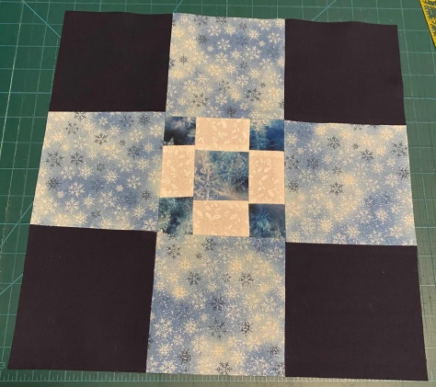
For April I choose a simple block called “ Nine Patch”. If you google it – different variations will appear in the search engine. Today we will create a 6” block , but it can also be made in different sizes. Here are the cutting measurements for the nine patch quilt block in five sizes: 6”, 9”, 12”, 15” and 18”.
Need |  | 6” | 9” | 12” | 15” | 18”
9 squares total
Fabric A:  5 squares | Cut | 2 1/2 | 3 1/2 | 4 1/2 | 5 1/2 | 6 1/2
Fabric B:  4 squares | Cut | 2 1/2 | 3 1/2 | 4 1/2 | 5 1/2 | 6 1/2

Fabric Requirements
Blue – 5 x 2 ½’ squares
White – 4 x 2 ½’ squares
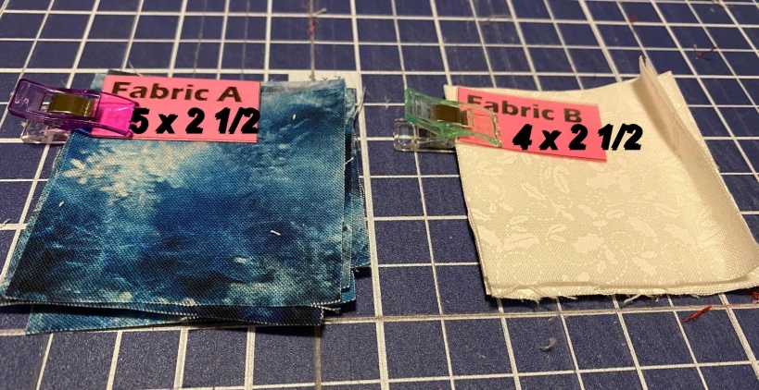

Assembly
Using the Blue and White 2 ½” pieces, alternate colors per pattern.
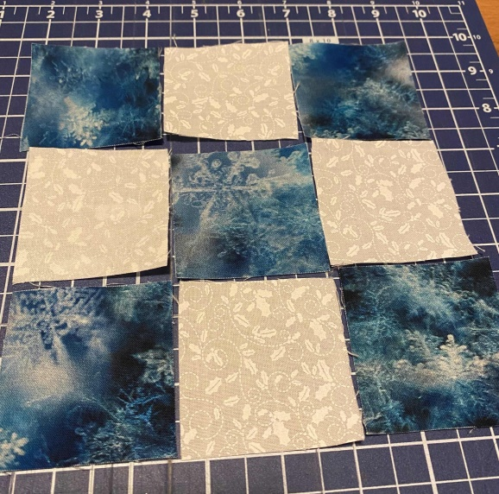

Sew using ¼” seams, press seams. Square the block to 5”
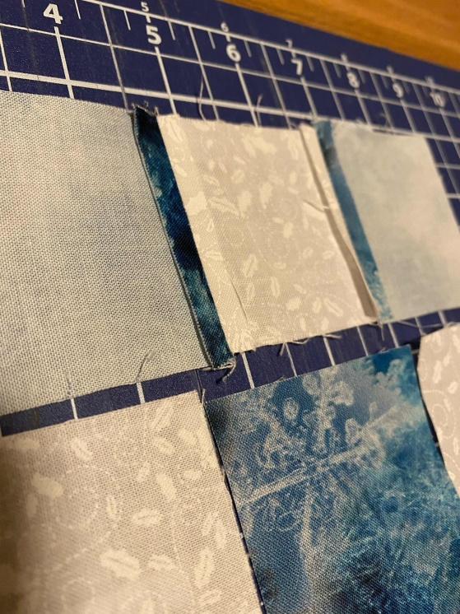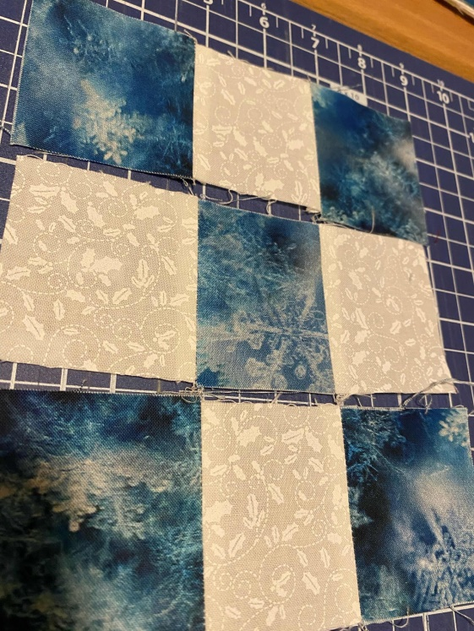
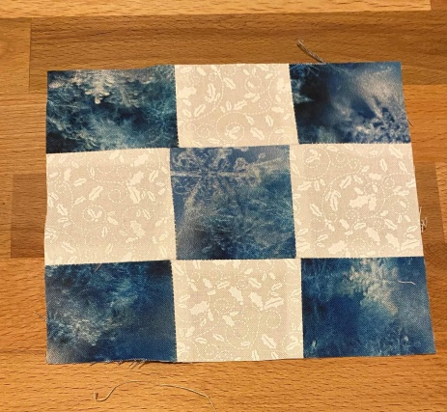
If you want a larger block continue on to double nine-patch making this last block the center piece.
Fabric Requirements
Light Blue – 4 x 5’ squares
Dark Blue – 4 x 5’ squares

Assembly
Using the Blue 5” pieces, alternate colors per pattern.
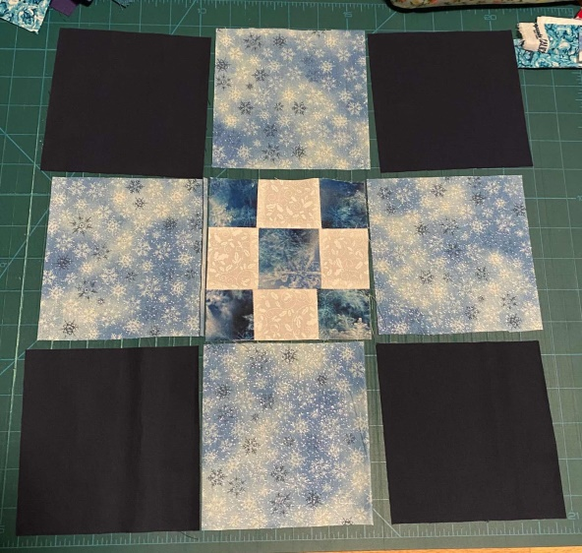

Sew using ¼” seams, press seams. Square the block to 12”

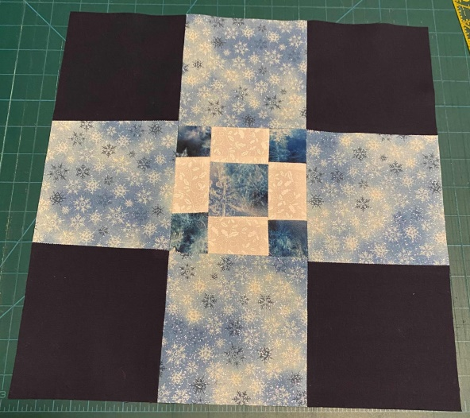

After you have created your master piece - share your picture in my Facebook group "Simply Stefanie Arts & Crafts".

