November

- Berry Lips & Nails
- Harvest Floral Arrangement
- Something Gingham
- Cappuccino Day Nov 8
- Thank a veteran Nov 11
- Make Pumpkin Pancakes
- Kindness Day Nov 13
- Family PJ Day Nov 14
- Button Day Nov 16
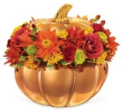
- Homemade Bread Day Nov 17
- Espresso Day Nov 23
- Bake a pie
- Thanksgiving Cooking
- Make Apple Cider Punch
- Make a cute snack
- Thanksgiving Day Nov 26
- Black Friday Nov 27
- Small Business Saturday Nov 28
- New Christmas Ornament
- Bake Cookies
- Mason Jar Day Nov 30

